**Roadblocks and Changes**

**Problem 1:**

**Changed my conceptual design to add a relationship between the Property entity and Geographical Area entity in order to display the data for the second Query (Part 2 B 2)**

Adding column ‘Geographical Area ID:



Adding Foreign Key Constraint to ‘Geographical Area ID’:

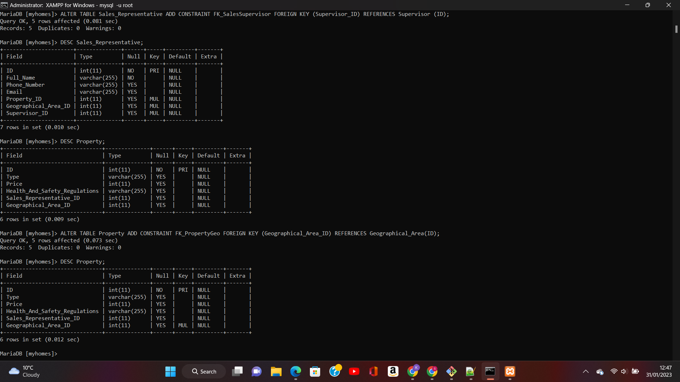

**Problem 2:**

**I realised that having the foreign key constraint ‘sales_representative’ in the Supervisor table would not work as the supervisor has a one to many relationship with the sales_representatives entity.**

**Therefore, Instead of having a foreign key for sales_rep_id in the supervisor table - I added a supervisor_id to the sales rep table.**

Adding column ‘Supervisor ID’:

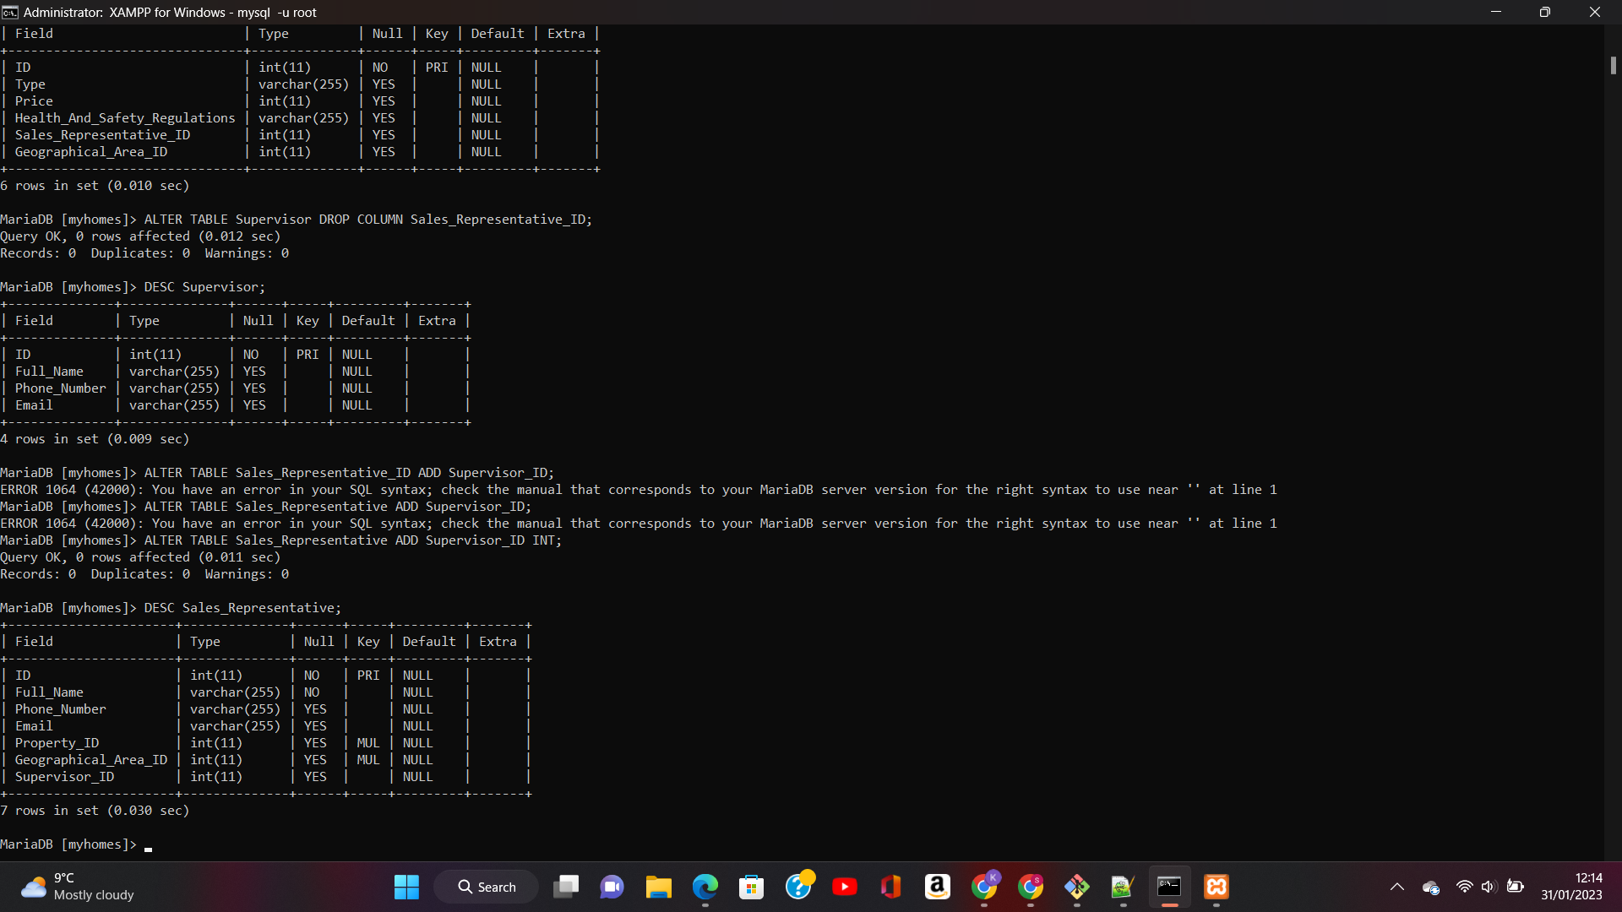

Add Foreign key constraint to ‘Supervisor ID’:

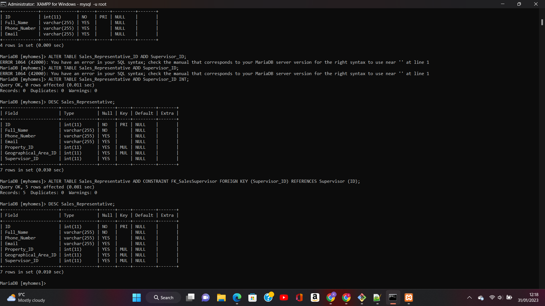

**Problem 3:**

**I realised that the foreign keys added for the relationship between sales rep and geographical area were incorrect. There should be a foreign key (Sales_Representative_ID) in the Geographical_Area table instead.**

Add Sales rep id to geo_area:



Add constraint (FOREIGN KEY) to SalesRepID:

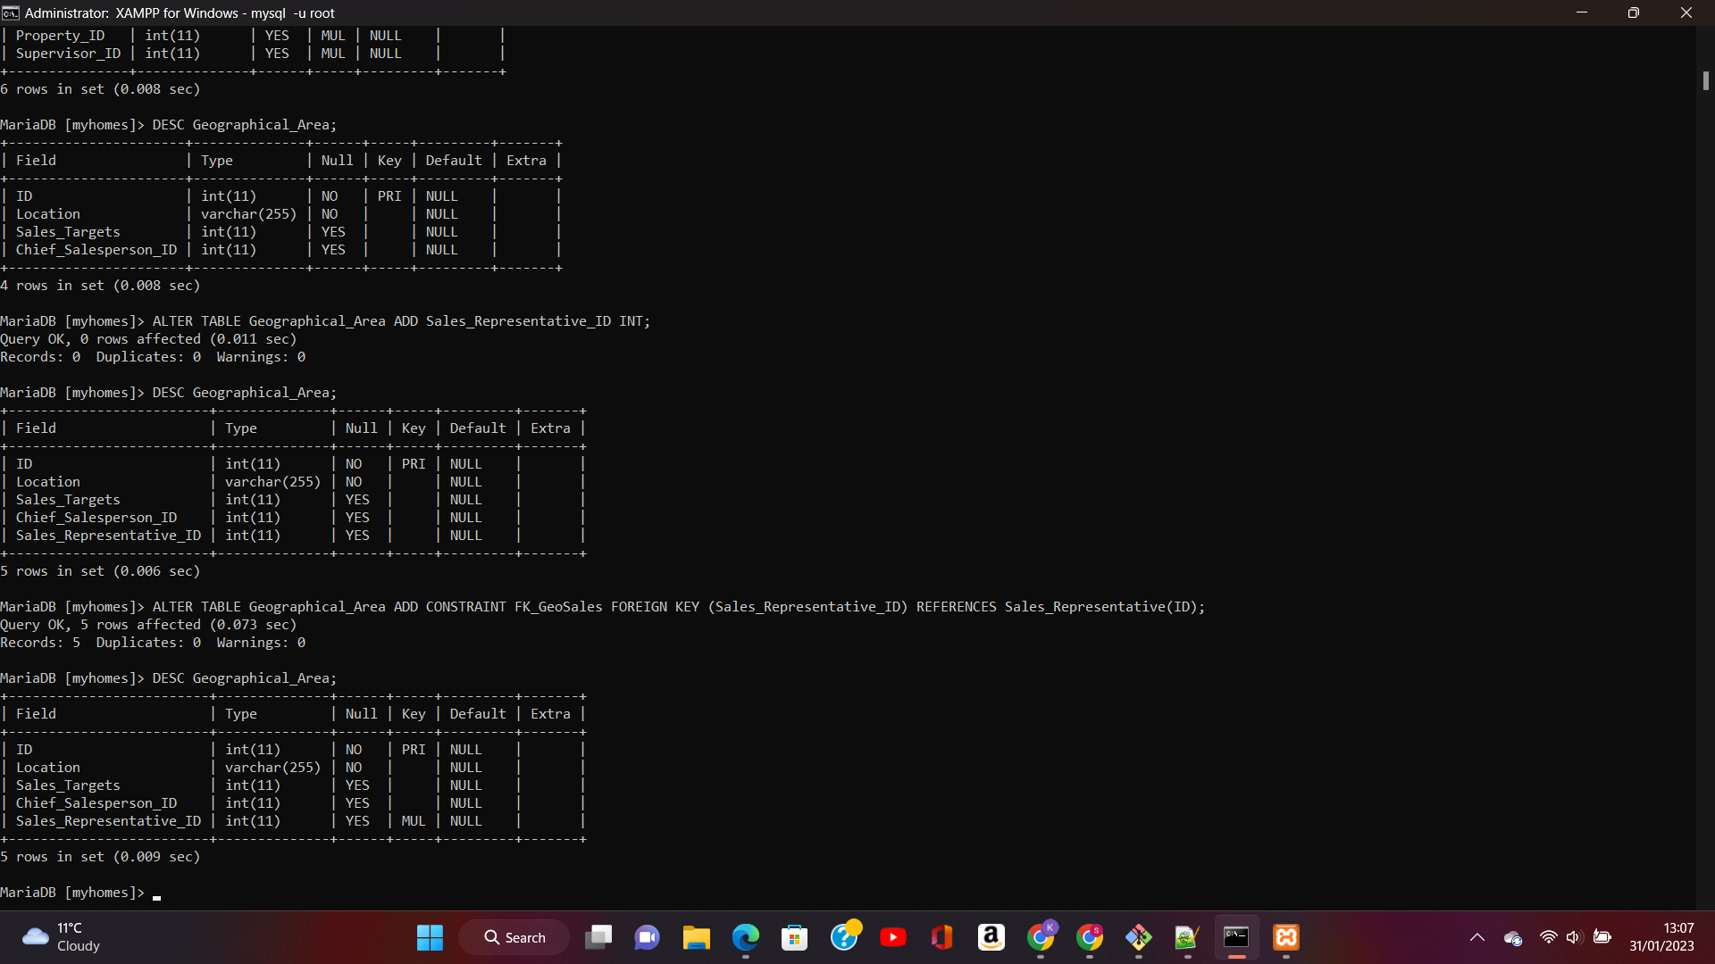

**Problem 4:**

**Since the second query (Part 2 (B) 2)) requires details of customers and with details of the areas - I decided to add a link between the Customers entity and the Geographical_Area entity, which would allow me to display data from both tables using INNER JOIN.**

Customer table with Geographical_Area_ID:

